Rapport annuel 2019-2020 Annual Report

Centre Flavie-Laurent Inc.

TABLE DES MATIÈRES/ TABLE OF CONTENTS
TABLE DES MATIÈRES/ TABLE OF CONTENTS 2
Rapport de la présidente 3
Chairperson’s Report 4
Rapport du directeur général 5
Executive Director’s Report 6
Information générale/ General Information 7
Activités/ Activities 9
Statistiques / Statistics 9
Collaborateurs / Partnerships 13
Banquet annuel 2017 13
2017 Annual Banquet 13
Fin spirituelle/ Spiritual Purpose 14
Besoins non comblés / Unmet Needs 15
Cadre éthique / Ethical Framework 16
Viabilité / Sustainability 16
Engagement à l’excellence / Commitment to Excellence 17
Donateurs / Donors……………………………………………………………………………………………………………………………….19

Rapport de la présidente

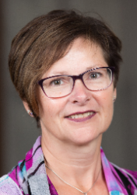

Chairperson’s Report

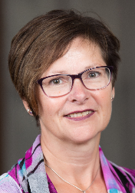
On behalf of the Board of Directors of Centre Flavie Laurent (CFL), I am honoured to share with you some highlights of the 2018 fiscal year. I am pleased to affirm that our organization continues to provide help and comfort to the impoverished and to those who are vulnerable by redistributing at no cost clothing, furniture and household items.

The Centre is blessed to have people who give graciously on a daily basis their time, talent, furnishings, clothing, and/or monetary donations. In turn, CFL provides the disadvantaged with some of life’s necessities. In 2018, the number of people who came to the CFL remained stable, but the continued increase in material donations enabled the Centre’s clients to select items they would typically buy if they had the financial means to do so. We sincerely thank all charitable donors who we rely on to fulfill our mission.

Storage challenges have required us to become creative in finding ways to continue to accept all clothing and household donations. A special thanks to the Archdiocese of St. Boniface who is allowing us to store a container on its property located in close proximity to the CFL to store overflow. Our recycling practices are increasing, and new partnerships are being forged that support other organizations while generating funds for the Centre that represent over 18% of our revenues. We foresee this revenue stream will increase in 2019.

In late 2017, the Catholic Health Corporation of Manitoba (CHCM) supported us by auditing of our human resource practices to help determine how to accomplish our objectives by bringing a systematic, disciplined approached to evaluate and improve the effectiveness of risk management, control, and governance processes. The completed report and its recommendations were used by the board and management to review its practices and implement some changes to its operations to become more effective in its operations. The audit was also used to support a funding application to The Winnipeg Foundation to assist us in building capacity within the organization. CFL was fortunate to receive support from the Foundation in the amount of $150,000 over a three-year period to hire an Operations Manager to improve the management of the organization. Providentially, this new funding has enabled us to improve our operations while maintaining a positive bottom line. Thank you CHCM and The Winnipeg Foundation for your support and trust in our abilities to govern our charitable organization effectively.

In closing, the Board of Directors cannot stress enough its gratitude to the outstanding generosity of its volunteers, funding partners, supporters, sponsors, and staff. I want to personally thank my fellow board members for your commitment and time you give to the CFL and look forward to Centre Flavie Laurent’s 40th anniversary in 2019.

Rapport du directeur général

Executive Director’s Report

2018, Flavie-Laurent Centre’s fourteenth year of operation, was its busiest overall since its opening in 2005. The staggering quantity of items that was distributed in the past twelve months is simply astounding and is a testament to the donors who provide them and our team for the work in processing these.
Growth has been the key word to describe our annual progress year after year, but growth has been particularly noticeable in one area - donor support.
For the last few years, we have seen the number of clients coming to the Centre for help on annual basis stabilize at about 7,000 families. On the other hand, the number and amount of donations we receive continues to increase on a yearly basis. In 2018, we increased our donation pick ups by 3% (3,427) and our incoming donations increased by 22% (14,394) over the previous year. This means that in 2018, we received almost sixty donations every day. Keeping in mind that a donation can mean a few bags of clothes or furniture from an entire household, this is quite remarkable.
The Centre collects donations from every area of Winnipeg, and even in rural communities like St. Claude, St. Jean Baptiste and Lac du Bonnet, to mention a few. CFLC’s existence is becoming widespread, and with the added feature of providing donor tax receipts for in kind donations, which we began issuing in an official manner in mid 2018, the growth appears unstoppable. We are obviously grateful for all these donations, but it is creating some immediate challenges, particularly in terms of a shortage of storage space, that we will have to resolve in the not too distant future. Our philosophy is that we cannot refuse a worthy donation because if we do, we may jeopardize any future donations from that contributor. The used article market is a very competitive one at this time, and we must be able to match, and hopefully surpass, the service being offered in this field of work elsewhere. In our case, we must also remember that an in-kind donor will often become a monetary donor down the line as they familiarize themselves with our mission.
We can say that in the past year Flavie-Laurent Centre didn’t do anything extraordinary, but with the help of generous donors we were able to provide people in need with basic life essentials. Along with our donors, that puts a smile on our faces.

Information générale/ General Information

Centre Flavie Laurent Inc.
450, boulevard Provencher Winnipeg (Manitoba) R2J 0B9
Téléphone/télécopieur (fax) 204-233-4936
www.cflc.info/fl@cflc.info
No d'enregistrement/Charitable registration no. 822377875 RR0001

Vision : Porter secours, aide et soulagement aux pauvres en cherchant à combler leurs besoins immédiats.

Mission : Le Centre Flavie-Laurent en concertation avec son milieu, apporte aide et confort aux personnes démunies et vulnérables en redistribuant gratuitement des articles vestimentaires, meubles et biens de maison.

Vision: To help, assist and bring relief to the poor by seeking to meet their immediate needs.

Mission: Flavie-Laurent Centre, in partnership with its milieu, provides help and comfort to the impoverished and to those who are vulnerable by redistributing at no cost clothing, furniture and household items.

Conseil d'administration/ Board of Directors

Président / Chair: Julie Turenne-Maynard
Vice-présidente/ Vice Chair: Rita Bourgeois
Trésorière/ Treasurer: Denis Freynet
Secrétaire/ Secretary: ModouFall Sall

Aminata Niane, Mariette Kirouac, Roland Saurette, Rachelle Frechette, Wilgis Agossa

Personnel/ Staff

Directeur général/ Executive Director: Gilbert Vielfaure

Superviseur des opérations

/Operations Supervisor : Raymond Sorin

Administration: Théogène Buhelwa
Mourtalla Ndiaye

Transport/transportation: Hubert Kuppe
Eugène Hébert
Joël Langelier

Expédtionet réception/
Shipping and Receiving: Caleb Dondo
Miguel St-Vincent
AfuzuTidjani

Bénévoles/ Volunteers

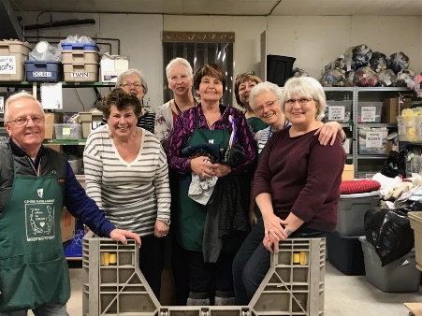
Chaque année, quatre-vingts personnes consacrent plus de 14000 heures à l'œuvre du Centre Flavie-Laurent de façon régulière (heures compilées au Centre, plus heures estimées).

Every year a team of about eighty people donate over 14,000 hours of their time to help on a regular basis at the CFLC (hours compiled at the Centre, plus estimated hours).

Activités/ Activities

Statistiques/ Statistics
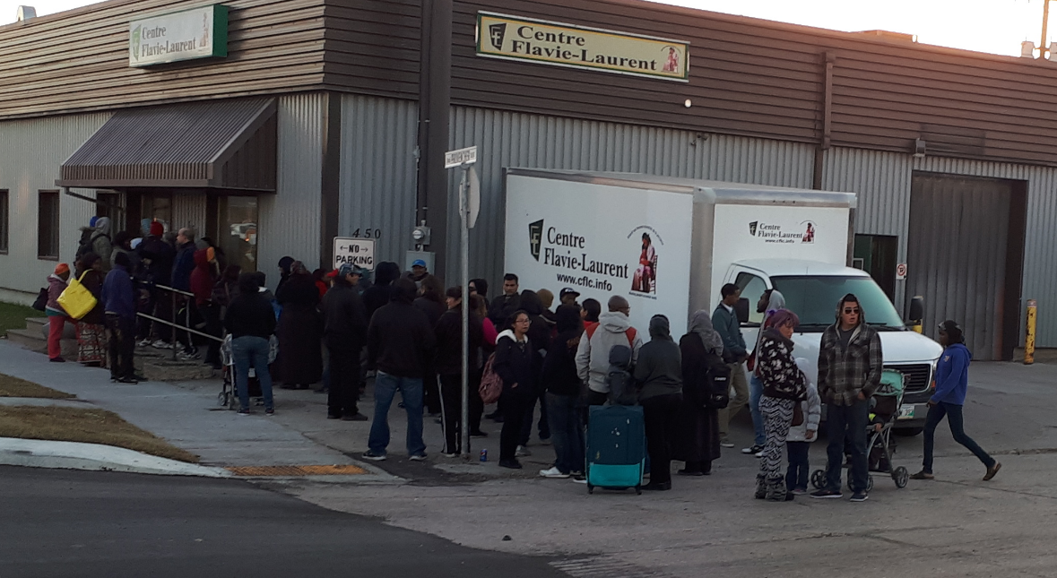

a) CLIENTS / CLIENTS

En 2018 :
- 6 940 clients ont effectué13 392 visites au Centre.

In 2018:

- 6,940 clients made 13,392 visits to the Centre.

Sexe / Gender

Quelques échantillonsd’articles distribués en 2018
/ Sampling of items distributed in 2018

9 511 sacs de vêtements / bags of clothes
3 519 matelas et sommiers / mattresses & boxsprings
4 990 boîtes de vaisselle / boxes of dishes & cups
3 204 divans et chaises de salon / sofas & arm chairs
151 chaises haute / high chairs
133 poussettes / strollers

54 414 articles en total / total articles distributed

b) DONS RECUEILLIS/ DONATIONS COLLECTED

En 2018, nous avons recueillis 3 427dons avec nos camions.
In 2018 we collected 3,427donations with our trucks.

c) DONS DÉPOSÉS/ DONATION DROP-OFFS

En 2018, il y a eu 14394 livraisons inscrites de dons apportés au Centre.
In 2018, 14, 394recorded donation drop-offs were made at the Centre.

(d) LIVRAISONS AUX CLIENTS/ DELIVERIES TO CLIENT HOMES
En 2018, nous avons fait 1 782 livraisons d'articles aux domiciles de nos clients.

In 2018, we made 1,782 deliveries of articles to client homes.

Collaborateurs/ Partnerships

En 2018-2019, le Centre Flavie-Laurent a continué de collaborer avec de nombreuses organisations et entreprises.

In 2018-2019, the Centre partnered with numerous organizations and businesses.

- Appareils Provencher Appliances
- Sleep Country Canada
- Envirotex Recycling Inc.
- Villa Rosa
- Université de Saint-Boniface
- Hope International
- Canadian Mental Health Association
- Siloam Mission
- Caisse Groupe Financier
- La Liberté (journal)
- Big Brothers, Big Sisters
- Katimavik

Banquet annuel 2018
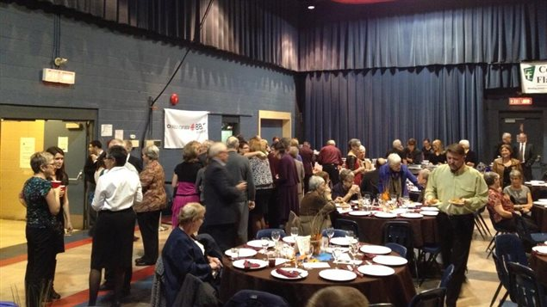
Le treizième banquet annuel du Centre a eu lieu le jeudi 15 novembre 2018 au Centre culturel franco-manitobain à Winnipeg. Trois cent cinquante (350) personnes ont assisté au banquet qui a généré 35 000 $ en profit grâce à leur présence, leurs dons, et la générosité des commanditaires de la soirée. Le banquet est aussi un excellent moyen de faire connaitre notre œuvre et de reconnaitre nos bénévoles.

2018 Annual Banquet
The thirteenth annual banquet of the Centre was held on Thursday November 15th, 2018, at the Franco-Manitoban Cultural Centre in Winnipeg. Three hundred (350) people attended the banquet which generated $35,000 in profit thanks to their presence, donations and the gracious support of the evening’s corporate sponsors. The banquet is also an opportunity to share information on the Centre and to recognize our volunteers.

Fin spirituelle/ SpiritualPurpose

The work of Flavie-Laurent Centre is primarily one that seeks to meets the physical needs of the impoverished, but we also understand that that people have spiritual needs that must be met. Conscious of this, we consistently seek to show forth God’s love for all in the efforts we render. We also provide many spiritual aids to our clients that include Bibles, rosaries, and statues, among other things. In various aspects of our messaging we include words from spiritual leaders such as Saint John Paul II, Mother Teresa of Calcutta and Mother d’Youville herself, to help transmit the Good News in a written format. Finally, we certainly encourage our volunteers and staff to pray for all the people we serve so that they may discover the salvation that is offered through Jesus Christ. In this regard, primarily through our website, we will be looking at new ways to invite the general public to both pray for our work and join us in interceding for the people we serve.

Centre Flavie-Laurent is aware of its spiritual roots and recognizes that this is the cornerstone of our mission. The support and resources we depend upon on daily are for us an expression of Divine Providence actively at work before our very eyes.

Besoins non comblés/ Unmet Needs

In 2018/19 Flavie-Laurent Centre continued its unique and critical work of serving all Manitobans living in poverty. Though we did not delve into any new expressions of our work of providing basic life essentials (clothing, furniture, appliances, beds, etc.) to the needy as such, we continued to seek ways of both improving and increasing the services we currently offer. The primary unmet needs we are striving to attain is quite simply to answer to all the requests made to us daily for the items we are trying to provide – there is such a demand for the provision of basic personal and household essentials, and so few organizations who are doing this. Though the Centre remains open to offering complimentary goods, such as food, when these come our way, are first focus is continue improving the services we offer.
Aside from the important work of providing items to clients, the Centre has come to recognize that is also provides a meaningful life experience to its team of volunteers. However, we feel that there is a great potential yet to be developed in this area. One of the thoughts is that we should create a repair area where volunteers could come help restore damaged items that we could then give away rather than discard. Our sense is that many men and, no doubt many women, may be interested in this kind of volunteer work.
The Centre would also like to be able to welcome larger groups, particularly school classes, who have expressed interest in volunteering. We are convinced that by involving young people, the Centre is sowing seeds of support and life for the future, as the youth will come to know and participate in the work we are doing.
The obvious challenge in creating a repair work area and in welcoming larger volunteer groups to the Centre is out shortage of space. We continue to examine the feasibility of extending hours of service for the volunteers, expanding our current facility, or finding other venues that would allow us to develop these two projects.

Cadre éthique/Ethical Framework

Since the Centre’s main work is the equitable distribution of goods to over 35,000 of our registered clients, integrity is at the heart of all our efforts. Providing a respectful service to our clients is our highest priority, and we make every effort to show respect and dignity to all individuals who come to us for assistance. In return, we also expect clients to treat our staff and volunteers with the same level of respect and dignity.

Disagreements and disputes occur regularly as people are desperate to obtain the items they require. Even in such challenging moments, we strive to develop practices and approaches that bring serenity to all situations in order to bring about efficient resolutions to conflicts. The 60-100 families that come to us every day represent a great variety of cultures and backgrounds which can be challenging on both a linguistic level and in ways of thinking. Patience and respectful communications are both effective means we employ to bridge these differences.

We have put in place policies and procedures to ensure that all staff and volunteers will be models of professionalism and respectful conduct at all times.

Viabilité/ Sustainability

Flavie-Laurent Centre continued to build upon its green revenue in 2018/19. In the fall of 2018, we entered into a new agreement with Envirotex based out of Toronto, to whom we sell surplus clothing and miscellaneous articles. We expect the revenue from these items shall increase by at least 25%, or about $20,000 annually, through this new agreement and because of an increase in article donations. Our green revenue through the recycling of metal and selling items that may not pertinent to our clients needs (ex: fridges and stoves since most rent apartments) also continued to increase in 2018. Overall, our total income from what we consider green revenue accounts for 33% of the entire 2018/19 annual budget of the Centre. This bodes very well for our future as we work our way towards decreasing external financial dependency.

The Center continues to reap from a strong volunteer workforce. Our latest estimates continue to indicate that our volunteers do the equivalent work of seven full time employees – this is quite a feat and a savings for CFLC! Volunteers remain an integral part of our mission and we are happy to report that things are going well in this area. In the upcoming year we will, however, continue to develop new volunteer recruitment strategies as well as review existing volunteer recognition policies in order to ensure a bright volunteer future.

Finally, the Centre continues to enjoy strong community support for its work. Our annual banquet remains a sterling example of this support with its consistent success story year after year. The 2018 annual banquet was no exception to this, with 350 people attending and an increasing support from corporate sponsors that enabled us to raise a record $35,000 in support of our work.

Engagement à l’excellence/ Commitment to Excellence

Our emphasis on the respect and dignity of the human person who comes to us seeking assistance, impels us to always strive to better the quality of our work. In practical terms, this means not only improving our client relations but, for example, also looking at new and innovative ways of fundraising and developing even more donor support. Because the nature of the work we do is so unique, there are not many, if any, models for us to emulate. Forcibly, this means that we must conjure up our own creative solutions and new strategies, which is both challenging and intriguing. We use this unique nature of our work as a motivational tool to find improvements in both the short and long terms.

As the organization has evolved over the years, we recognized the need in 2017 to undertake an organizational audit to highlight FLC’s strengths and weaknesses. Recommendations from this audit included the addition of a new Operations Manager (Raymond Sorin) and change its organizational chart to include a Transportation, Warehouse & Logistics Team Lead (Mourtalla Ndiaye). The Operations Manager can now support FLC’s Executive Director in implementing its strategic objectives and respond to our commitment to excellence. We are very grateful to The Winnipeg Foundation who supported our request for financial support over a three-year period to help our Centre build capacity.

As we move forward in our mission, we look to provide a stronger framework within which we can provide more enhanced training and development opportunities for our staff and volunteers. In the past year, we have done more in this area than at any other time in our existence, and we hope to build on this further in the future. We also look to develop volunteering opportunities within our organization to include large groups and the participation of more school aged young people.

In 2018, we have considerably strengthened our donor base by increasing donor motivation and retention through the issuance of tax receipts for in kind donations. This then allows us to build relationships with these people in order to develop future possibilities. Stronger donor relationships had been a key recommendation made to us by a media relations firm who analyzed our situation in the past year.

In all ways, we are always attentive to be the best we can be. Our experience has been that as we have strived to develop a giving heart, opportunities often arise providentially that turn good intentions into good actions. For Flavie-Laurent Center, excellence is not an option, it is a way of life.
2018 Flavie-Laurent Centre Donors and Sponsors

We wish to express our sincere gratitude to Flavie-Laurent Centre’s 1264 donors and sponsors in 2018, as well as our fundraising honourary chairs, Mrs. Mona Dupuis and Daniel Boissoneault.
Commanditaires / Sponsors
ASSOCIATION DES RÉSIDENTS PLACE DES MEURONS
CAISSE GROUP FINANCIER
CENTRE SCOLAIRE LÉO-RÉMILLARD
CHEVALIERS DE COLOMB #3158
CHEVALIERS DE COLOMB CONSEIL STS. MARTYRS #6885
CONSULTATION DEROCHE CONSULTING INC.
CONSULTATION GISELE BARNABÉ CONSULTING
CORPORATION CATHOLIQUE DE LA SANTÉ DU MANITOBA
DEVELOPMENT ASSISTANCE INTERNATIONAL INC.
DORAIS CHARITIES INC.
ENCORE BUSINESS SOLUTIONS
G.J. ANDREWS FOOD AND WINE SHOP
GLOBAL PHILANTHROPIC
JOURNAL LA LIBERTÉ
KNIGHTS OF COLUMBUS #8124
KNIGHTS OF COLUMBUS #3538
LES FILLES DE LA CROIX
LES MISSIONNAIRES OBLATES DE ST-BONIFACE
PAROISSE ST-JEAN-BAPTISTE
PAYWORKS
SISTERS OF THE HOLY NAMES OF JESUS & MARY
SOEURS DE SAINTE-CROIX
SOEURS GRISES DU MANITOBA INC.
ST. BONIFACE / ST. VITAL KIWANIS CLUB
TÉTRAULT WEALTH ADVISORY GROUP
THE WINNIPEG FOUNDATION
UNIVERSITY OF WINNIPEG
VICKAR COMMUNITY CHEVROLET

